Packet Switching Networks and Algorithms

1-

Five stations (S1-S5) are connected to an extended LAN through transparent bridges (B1-B2), as shown in the
following figure. Initially, the forwarding tables are empty. Suppose the following stations transmit
frames: S1 transmits to S5, S3 transmit to S2, S4 transmits to S3, S2 transmits to S1, and S5 transmits to S4.
Fill in the forwarding tables with appropriate entries after the frames have been completely transmitted.
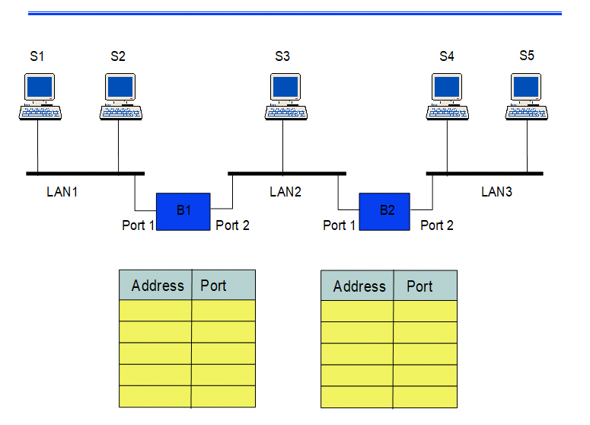
ans:
Updated table is mention below
B1
station | port
S1 | 1
S2 | 2
S3 | 2
S4 | 1

B2
station | port
S1 | 1
S2 | 1
S3 | 2
S4 | 2

2-

Part (a) of the figure below shows a subnet. The first four columns of part (b) show the delay vectors received
from the neighbors of router J. Suppose that J has measured its delay to its neighbors, A, I, H, and K as 8,10,12,
and 6 msec, respectively. Please compute the new route, i.e., the new estimated delay and the new outgoing line,
from J to routers C and G, respectively. Show the main calculation procedures.

ans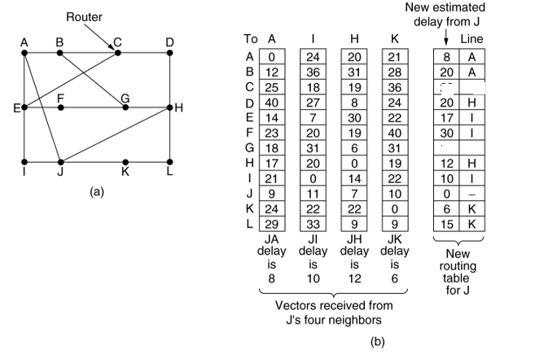
ans:
For J to G route -
Consider how J computes its new route to router G. It knows that it can get to A in 8 msec, and A claims to be able to get to G in 18 msec, so J knows it can count on a delay of 26 msec to G if it forwards packets bound for G to A.

· Similarly, it computes the delay to G via I, H, and K as 41 (31 + 10), 18 (6 + 12), and 37 (31 + 6) msec, respectively. The best of these values is 18, so it makes an entry in its routing table that the delay to G is 18 msec and that the route to use is via H.

For J to C route -
we will follow same procedure here.
J to C route delay via A = J to A (8) + A to C (25) = 33 msec
J to C route delay via I = J to I (10) + I to C (18) = 28 msec
J to C route delay via K = J to K (6) + K to C (36) = 42 msec
J to C route delay via H = J to H (12) + H to C (19) = 31 msec
so it makes an entry in its routing table that the delay to C is 28 msec and that the route to use is via I.

3-

Consider the network in Figure.
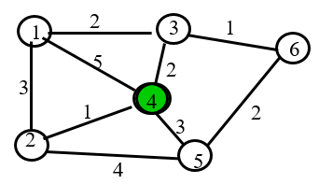

a) Use the Dijkstra algorithm to find the set of shortest paths from node 4 to other nodes.

b) Find the set of associated routing table entries (Destination, Next Hop, Cost)

ans:
Here we are going call stations or nodes as 'D'.
4 is the starting point so the execution of Dijkstra's algorithm is as mention below-

iteration |  | D1 | D2 | D3 | D4 | D5 | D6
1ST iteration | D6 | 5 | 1 | 2 | 0 | 3 | -
2ND iteration | D5 | 4 |  | 2 |  | 3 | -
3RDiteration | D4 | 4 |  |  |  | 3 | 3
4TH iteration | D3 | 4 |  |  |  |  | 3
5THiteration | D2 | 4
6TH iteration | D2

PATH FROM 4 TO OTHER NODES -
D4 = {D4} = 0
D4 to D1 = {D2 D1} = 4
D4 to D2 = {D2} = 1
D4 to D3 = {D3} =2
D4 to D5 = {D5} =3
D4 to D6 = {D3 D6} =3

